Olá, candidato(a),

Dando continuidade ao nosso processo, temos um desafio para te propor.

Analisar informações sobre gosto musical que estão no banco SQLite chinook.db para presentearmos nossos clientes.

1. Selecionar através de SQL os 3 gêneros mais vendidos no Brasil

select tracks.Name,sum(invoice_items.Quantity) as Total_Vendas

from invoice_items

left join tracks on invoice_items.TrackID = tracks.TrackId

group by tracks.GenreId

order by Total_Vendas DESC

limit 3;

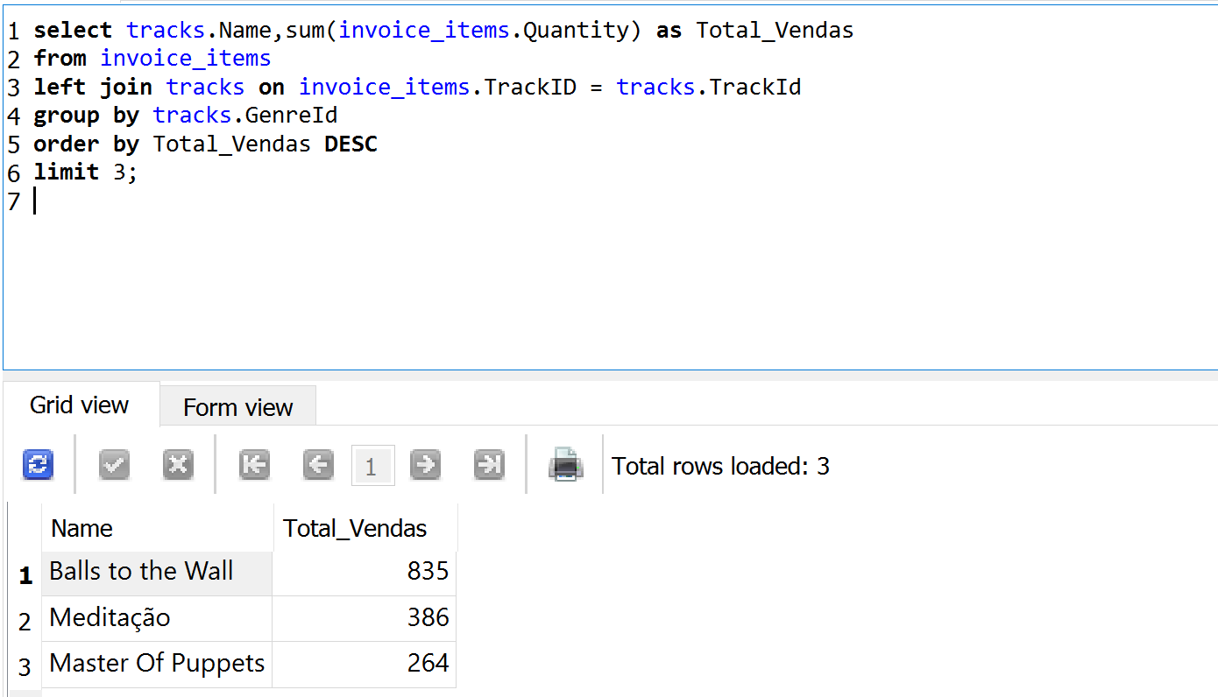

1. Selecionar através de SQL o total de vendas *(quantidade e valor total)* de cada faixa do álbum 'Mais Do Mesmo'

select albums.Title, tracks.Name, sum(invoice_items.UnitPrice) as Total_Faturamento,

sum(invoice_items.Quantity) as Total_Volume

from invoice_items

left join tracks on invoice_items.TrackID = tracks.TrackId

left join albums on albums.AlbumId = tracks.AlbumId

where invoice_items.TrackID >= 1686 AND invoice_items.TrackID <=1701

group by tracks.Name

order by Total_Faturamento DESC;

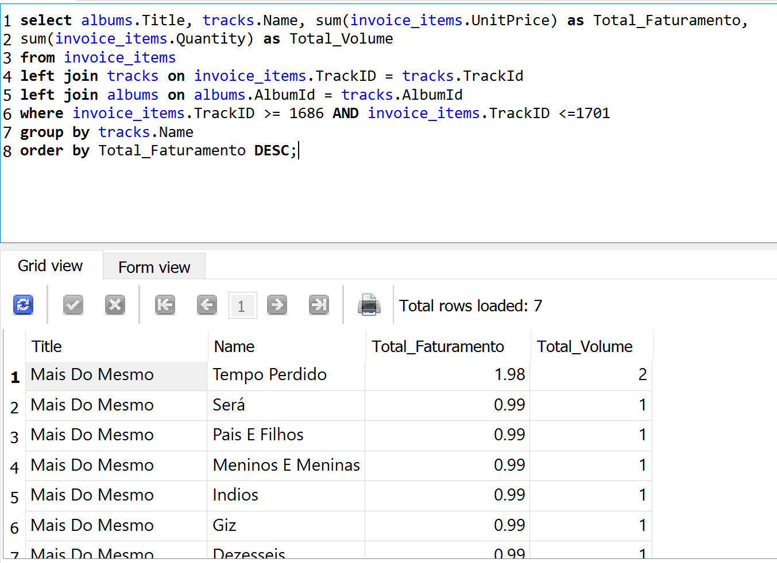

1. Selecionar através de SQL o valor total de venda por nome completo do vendedor(a) em 2012

select (employees.FirstName || " " || employees.LastName) as Funcionario,

round(sum(invoices.Total),0) as Total

from invoices

left join customers on invoices.CustomerId = customers.CustomerId

left join employees on customers.SupportRepId = employees.EmployeeId

where substr(invoices.InvoiceDate,1,4) = "2012"

group by customers.SupportRepId

order by Total DESC;

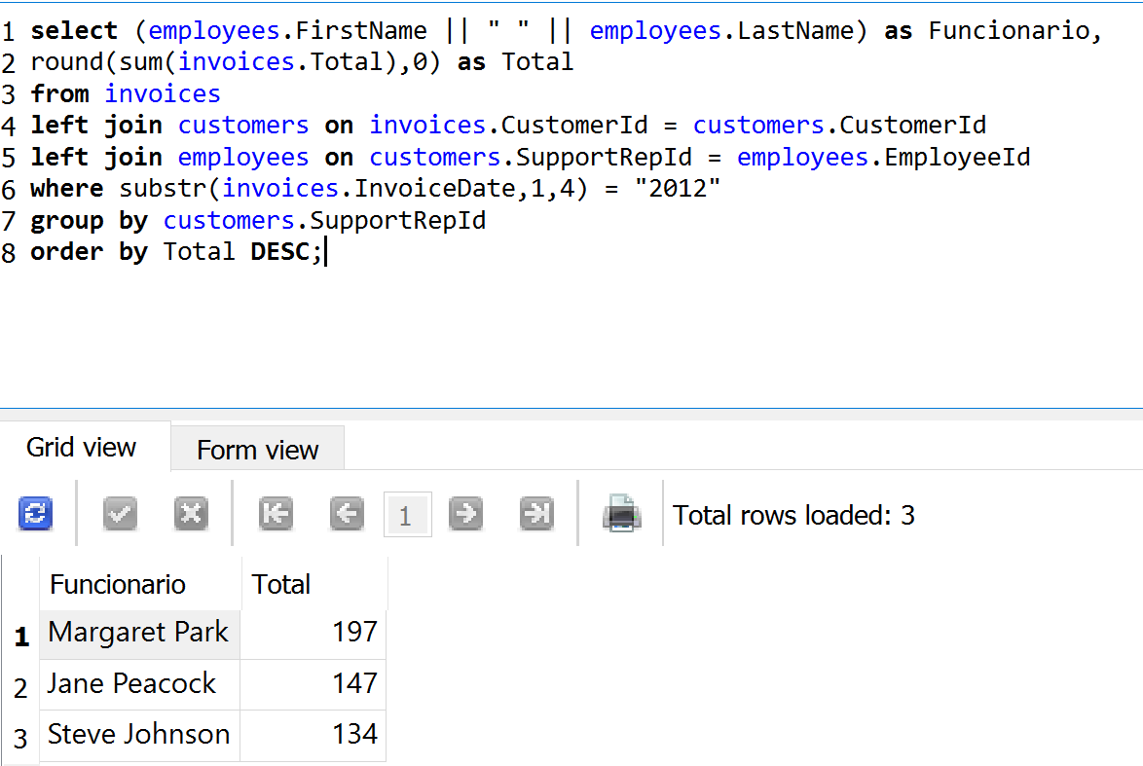

1. Listar em uma única query o total de músicas, total de músicas com o tipo de mídia MPEG e o total com tipo de mídia AAC para cada tipo de gênero. Exemplo de saída:

|  |  |  |  |
| --- | --- | --- | --- |
| Gênero | Total de Músicas | Total para tipo de mídia MPEG | Total com tipo de mídia AAC |
| Rock | 20 | 10 | 10 |
| Jazz | 15 | 10 | 5 |

select genres.Name, count(tracks.Name) as Total_Musicas,

(select count(tracks.Name) from tracks where media_types.Name like "%MPEG%" AND genres.GenreId = tracks.GenreId) as Total_MPEG,

(select count(tracks.Name) from tracks where media_types.Name like "%AAC%" AND genres.GenreId = tracks.GenreId) as Total_AAC

from tracks

left join genres on genres.GenreId = tracks.GenreId

left join media_types on media_types.MediaTypeId = tracks.MediaTypeId

group by tracks.GenreId

order by Total_Musicas DESC;

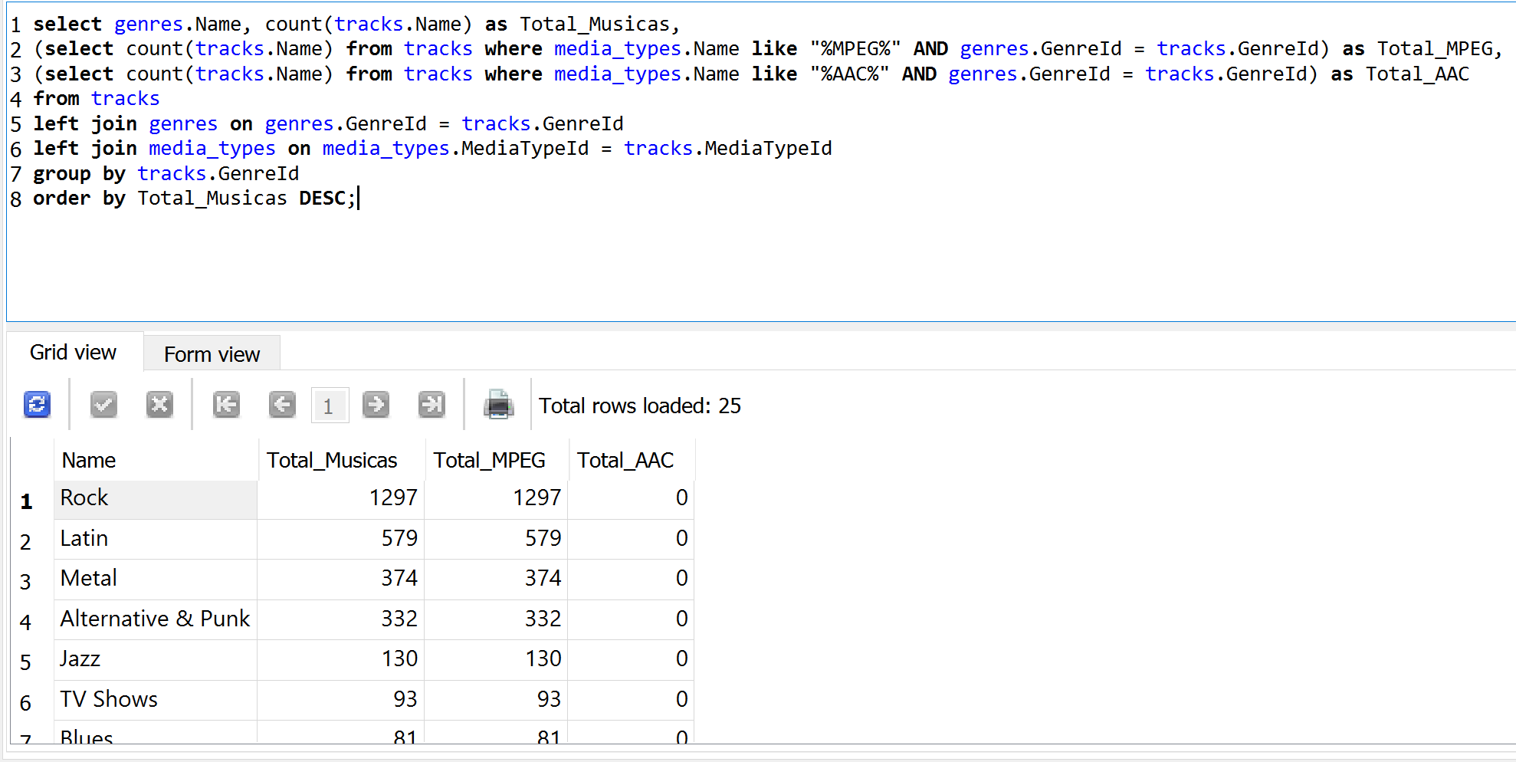

**Links úteis:**

Baixar chinook.db:​ <https://cdn.sqlitetutorial.net/wp-content/uploads/2018/03/chinook.zip>

Modelo de dados do chinook.db:[https://www.sqlitetutorial.net/sqlite-sample-database](https://www.sqlitetutorial.net/sqlite-sample-database/)​ [/](https://www.sqlitetutorial.net/sqlite-sample-database/)